NPAFC Doc.

Rev.

# Preliminary Findings of the International Year of the Salmon Pan-Pacific Winter High Seas Expedition Onboard the NOAA Ship *Bell M. Shimada,* February 1-March 7, 2022

by

Laurie Weitkamp1, A, Ed Farley1,B, Alex Andrews1, B, Alicia Billings1, A, Brandon Chasco1, A, Christoph Deeg2, C, Iris Ekmanis1, D, Sabrina Garcia1, E, Ben Gray1, E, Katie Howard1, E, Charles Kovach1, F, Steve Lindley1, G, Marisa Litz1, H, Ryan McCabe1, D, Jamal Moss1, B, Jim Murphy1, B, Dave Nicolls1, B, Alexei Pinchuk1, I, Tanya Rogers1, G, Kyle Shedd1, E, Wess Strasburger1, B, Genyffer Troina2, C, Abi Wells1,A, J, Brian Wells1, G , and Eric Wisegarver1, D.

Submitted to the

### NORTH PACIFIC ANADROMOUS FISH COMMISSION

by

USA1 and Canada2

May 2022

**THIS PAPER MAY BE CITED IN THE FOLLOWING MANNER:**

Weitkamp, L., E. Farley, A. Andrews, A. Billings, B. Chasco, C. Deeg, I. Ekmanis, S. Garcia, B. Gray, K. Howard, C. Kovach, S. Lindley, M. Litz, R. McCabe, J. Moss, J. Murphy, D. Nicolls, A. Pinchuk, T. Rogers, K. Shedd, W. Strasburger, G. Troina, A. Wells, B. Wells, and E. Wisegarver. 2022. Preliminary Findings of the International Year of the Salmon Pan-Pacific Winter High Seas Expedition Onboard the NOAA Ship *Bell M. Shimada,* during February 1-March 7, 2022. NPAFC Doc. [insert number]. 31 pp. USA (Available at https://npafc.org).

**Affiliations:**

A NOAA Fisheries, Northwest Fisheries Science Center, Newport, OR and Seattle, WA

B NOAA Fisheries, Alaska Fisheries Science Center, Juneau, AK

C University of British Columbia, Vancouver, BC

D NOAA Office of Oceanic and Atmospheric Research, Pacific Marine Environmental Laboratory, Seattle, WA

E Alaska Department of Fish and Game, Anchorage, USA

F NOAA National Environmental Satellite Data and Information Service, College Park, MD

G NOAA Fisheries, Southwest Fisheries Science Center, Santa Cruz, CA and Newport, OR

H Washington Department of Fish and Wildlife

I University of Alaska-Fairbanks, Juneau, AK

J Lynker, Leesburg, VA 20175

**Abstract**

The objective of the 2022 International Year of the Salmon Pan-Pacific Winter High Seas Expedition was to demonstrate the utility of an international pan-Pacific winter ecosystem survey to understand how increasingly extreme climate variability in the North Pacific Ocean and associated changes in the physical environment influence the abundance, distribution, migration, and growth of Pacific salmon and other pelagic species. For the 2022 Expedition, five vessels were deployed during February–April into four zones of the North Pacific Ocean. The NOAA Ship *Bell M. Shimada* covered zone four in the central Gulf of Alaska, an area of approximately 640,000 km2, between February 1 and March 7, 2022. An international research team of 26 scientists representing U.S. and Canada participated on the NOAA Ship *Bell M. Shimada;* Chief Scientists were Ed Farley and Laurie Weitkamp. We successfully completed 21 tows of a surface trawl, and caught 162 salmon consisting of 69 sockeye salmon, 64 chum salmon, 13 pink, 10 coho salmon, 6 Chinook salmon, but no steelhead. Other common taxa caught in the trawl included pelagic squids, myctophids, and jellyfish. In addition, we completed 51 CTD casts and 19 bongo and 10 Tucker trawl plankton tows. This report provides an overview of the methods, samples collected, and some preliminary results from the survey.

**Keywords:** Pacific salmon, North Pacific Ocean, international collaboration, winter salmon ecology

**Introduction**

The 2022 International Year of the Salmon Pan-Pacific Winter High Seas Expedition was an international collaborative effort between Canada, Japan, the Republic of Korea, the Russian Federation, and the United States of America. The 2022 Expedition was the largest multinational survey to study salmon in the North Pacific Ocean during the winter and builds on previous International Year of the Salmon (IYS) Expeditions into the Gulf of Alaska in 2019 and 2020 (Pakhomov et al. 2019, Somov et al. 2020). A changing climate and associated anomalous events in the North Pacific Ocean are progressively exposing salmon to conditions outside normal climate cycles. These expeditions offer important insights to help further our understanding of how changing ocean conditions affect salmon in the open ocean.

To date, significant resources have been invested to better understand and manage the freshwater phase of the salmon life cycle to maximize salmon productivity and restore declining populations. Despite these research efforts, we still struggle to predict and understand inter-annual fluctuations in salmon productivity. To fully address current management challenges, we need to better understand the physical, chemical and biological drivers of salmon growth and survival in the ocean. The IYS 2019, 2020 and 2022 Expeditions have begun to address these knowledge gaps. Additionally, these expeditions offered excellent opportunities for collaborating multilaterally with salmon-producing countries across the North Pacific to build knowledge that can improve our ability to manage and sustain salmon into the future.

The 2022 Expedition occurred between February and April of 2022 and involved five research vessels that sampled stations within four zones across the North Pacific Ocean. The overall objective of the 2022 Expedition was to demonstrate the utility of an international pan-Pacific winter ecosystem survey to understand how increasingly extreme climate variability in the North Pacific Ocean and the associated changes in the physical environment influence the abundance, distribution, migration, and growth of Pacific salmon and other pelagic species. The specific sub-objectives of the 2022 Expedition were as follows:

1. Determine species and stock-specific ocean distributions, relative abundances, condition of juvenile and immature/mature salmon, and factors or mechanisms controlling their growth and survival;

2. Document the spatial and temporal variation in physical and biological oceanographic conditions;

3. Document the distribution, condition, and standing stocks of zooplankton and nekton that serve as the prey base for Pacific salmon and associated marine fishes;

4. Demonstrate the ability to effectively collaborate across the five North Pacific Anadromous Fish Commission (NPAFC) parties and our partners to conduct integrated ecosystem research that will support the sustainable management of salmon in a rapidly changing North Pacific Ocean.

This is a preliminary report of the results from the 2022 IYS Expedition collected onboard the NOAA Ship *Bell M. Shimada*. A more detailed report from each vessel will be compiled into an NPAFC Technical Report and published before the end of 2022. All participants agreed that all data collected as part of the 2022 IYS Expedition will be made publicly available.

**Materials and Methods**

The key methodological approach was to conduct an international survey of salmon and the epi-pelagic ecosystems in offshore regions of the North Pacific Ocean in the winter to provide a seasonal picture of the distribution, migration, and ecology of salmon and associated species in the high seas. The survey design included concurrent surveys between February–April 2022 within four zones of the North Pacific Ocean (Figure 1).

An ecosystem survey utilizing a surface trawl to capture overwintering salmon was conducted in zone 4 of the IYS 2022 Pan-Pacific Winter High Seas Expedition survey area (Figure 1) from February 1 to March 7, 2022, onboard the *Bell M. Shimada*. This vessel covered roughly 320,000 km2 of the overall survey area. Twenty six scientists participated onboard the *Bell M. Shimada*, 24 from the U.S. and 2 representing Canada. The science team included salmon biologists, ecologists, geneticists, oceanographers, acousticians, and remote sensing specialists. The scientific team represented three branches of NOAA (National Marine Fisheries Service [Alaska, Northwest and Southwest Fisheries Science Centers], Office of Oceanic and Atmospheric Research [Pacific Marine Environmental Laboratory], and National Environmental Satellite, Data, and Information Service), Alaska Department of Fish and Game, Washington Department of Fish and Wildlife, University of Alaska, University of Washington, and University of British Columbia.

The detailed sampling protocols are outlined in Pakhomov et al. 2021. The survey onboard the *Bell M. Shimada* was divided into two legs starting in Port Angeles, Washington, and ending in Newport, Oregon, with a port call midway in Kodiak, Alaska. Both legs covered the eastern two north-south transects (151.5°N, 147°N; due to inclement weather and ship repair issues, we were unable to sample the western-most transect ([56°N]). In total, 28 stations and 21 trawl sets were completed in zone 4 onboard the *Bell M. Shimada* with an average distance of 60 nm between stations (Figure 1).

The typical survey stations conducted during both daytime and nighttime consisted of:

1. CTD-Rosette casts to 100 m, and a 2nd cast to 500 or 1000 m. Water samples collected during these casts were analyzed for:
   1. Dissolved oxygen
   2. Dissolved nutrients
   3. Chlorophyll-a
   4. eDNA
   5. Particulate organic matter (POM)
   6. High-performance liquid chromatography (HPLC)
   7. Flow cytometry
2. Plankton nets: vertical Bongo net deployed to 250 m, and oblique Tucker trawls to 150m (nighttime only).
3. Midwater trawl adapted to fish at the surface towed at 4.5-5 knots for one hour (range 0.5 to 1.5 hours) in the top 30 meters of the water column.

Additional activities occurring during the cruise included:

1. Hydroacoustic measurements throughout the full survey area.
2. Flow-through thermosalinograph measurements throughout the full survey area.
3. Opportunistic observations of marine mammals and seabirds.
4. Deployment of two drifters and three Argo floats.
5. Measure in- and above-water water-leaving radiance (Lwn) for the validation of ocean color satellites (Leg 1 only).
6. Recording macroplastics passing the ship using video footage and retain myctophids and squid to assess ingestion of microplastics.
7. Measure the strength of the Alaska stream from five 1000 m CTD deployments.
8. Tag a salmon shark (*Lamna ditropis*) with Smart Position and Temperature (SPOT) satellite transmitting tag and a Pop-up Satellite Archival tag (PSAT).
9. Collect vertebrate voucher specimens for NOAA forensic capabilities.

Details on the protocols used for these activities are provided below.

**1. CTD Deployment and Processing**

Two CTD casts were made at most stations. The first cast was shallow (100m), and water samples were collected for eDNA, HPLC, and POM analyses. The second cast was made to either 500 m or 1,000 m, and water was collected for salinity, nutrients, dissolved oxygen, chlorophyll, and flow cytometry. Five CTD casts to 1,000 m were made consecutively to measure the strength of the Alaska Stream; these stations were located between 56° 28.6’N, 151° 58.4’W and 55° 59.7’N, 151° 29.3’W. Four of these casts were strictly to measure water column properties (no water samples collected), and the fifth was treated as a full station with water collection, zooplankton, and fishing.

**2. Water Sample Collection and Processing**

Dissolved oxygen

Dissolved oxygen was typically collected from one or two depths from the 500m-deep CTD casts, which varied by station (sample depth ranged from 5 - 500m). During three 1000m CTD casts (stations 10, 18, and 25), samples for dissolved oxygen were collected at 12 depths (5, 25, 50, 75, 100, 150, 200, 300, 450, 600, 750, and 1,000 m). These samples were processed by Winkler titration using the amperometric technique.

Dissolved nutrients

Water samples for nutrients were collected at 5, 25, 50, 75, 100, 150, 200, 300, 400, and 500 m in the 500 m deep CTD, and 5, 25, 50, 75, 100, 150, 200, 300, 450, 600, 750, and 1,000 m in the 1,000m deep CTD. Collected water was frozen.

Chlorophyll-a

Water samples for chlorophyll-a were collected at 5, 25,50, 75, 100, and 150 m during both 500 m and 1000 m CTD casts. For each depth, 100-250 ml of water was filtered through a 25 mm GF/F filter. The filter was placed in a cryovial and stored in the ship’s the -80°C freezer.

Environmental DNA (eDNA)

Water for eDNA was collected at four depths during the 100 m CTD casts: 5, 25, 50, and 100m. Duplicate eDNA samples each used 5 L of water from each depth. Water was pumped and filtered through a hollow membrane filtration cartridge (approximately 0.5 μm pore size) directly from the Niskin bottle using the IYS filtration system. All CTD casts for eDNA were conducted immediately upon arrival at a station prior to any other collection activity (e.g., other CTD casts, zooplankton, fishing) to minimize contamination of samples.

Hundreds of eDNA samples were also collected while the ship was underway from the ship’s flow- through water system, which collects water at 3 m depth. These ‘surface’ eDNA samples used the same hollow membrane filtration system as those collected from the CTD casts. All filters (from both CTDs and flow through system) were preserved with RNALater and stored at 4°C.

Particulate organic matter (POM)

Water samples for all POM samples were collected at 5 m from the 100m CTD cast and filtered through pre-combusted and pre-weighed GF/F filters. Samples for fatty acids used 47 mm filters and used 5-10 L of water. POM samples for stable isotopes, organic carbon and nitrogen used 25 mm filters and replicate 2 L water samples. Both filter types were stored in the -80°C freezer.

High-performance liquid chromatography (HPLC)

Water samples for duplicate HPLC pigments were collected at 5 m from the 100m CTD cast. Four L of water were filtered through a 25 mm Whatman GF/ F filter for each duplicate and stored in the -80°C freezer.

Flow cytometry

Water samples for flow cytometry were collected at 5, 25, and 50 m from the 500 and 1000m deep CTD casts. Each sample consisted of approximately 2 mL of water, preserved with 10% paraformaldehyde and stored in the -80°C freezer.

**3. Plankton Net Deployment and Processing**

Bongo net

A bongo plankton net was deployed vertically to 250m. The frame for each net was 60 cm in diameter, and both nets had a 250 μm mesh. Plankton captured in net 1 were preserved in formalin for taxonomy. Plankton captured in net 2 were size fractionated using 4mm, 2mm, 1mm, 0.5mm, and 0.25mm sieves, and then frozen at -80°C. Half of the net 2 samples will be used to estimate biomass, and the other half will be used for either energy density or trophic biomarkers (fatty acids and stable isotopes).

Tucker Trawl

A Tucker trawl (1 m2 frame, 505 μm mesh) was deployed at night at a 45° wire angle to 150 m. Plankton captured by the Tucker trawl were preserved in formalin.

**4. Midwater Trawl Deployment and Processing**

A CANtrawl spread with two 5 m2 doors was fished at each station where weather conditions allowed safe operations. During deployment, a Simrad ITI sensor was placed on the footrope to wirelessly measure the vertical opening. When fully fishing, the trawl had an average net opening of 28.5m height (range 25.0-31.38 m; Table 1) and estimated 43 m width. The net itself is 198 m long, with a 12 mm mesh liner in the codend. During the survey, the warp length was 200 m.

Tow duration was measured from the time the net was fully deployed, determined when the footrope was at approximately 30m depth or less, and the ship’s speed had stabilized (mean speed at the start of trawling was 4.1 kts [speed over ground]). The tow ended when net retrieval began, although it typically took another 20-25 minutes to completely retrieve the net. Trawl duration was 1, 1.5, or 2 hours in length (longer tows were intended to increase the catch of salmon). One exception (Station 19, 50.0°N, 151.5°W) occurred when the tow was restricted to 0.5 hours due to large numbers of jellyfish seen in the water prior to net deployment and concerns about damaging the gear.

Once the net was fully retrieved, the codend was emptied and contents were placed in fish baskets. All trawl contents were identified to the lowest practical taxon, counted, weighed (total or individual), and measured (fork or total weight for fish, mantle length for squid, bell diameter for jellyfish). A variety of tissues or whole bodies were collected and preserved (frozen at either -20 or -80°C, or preserved in formalin [stomach contents only]).

For salmon, these tissues and their subsequent analyses included:

* Scales (age, growth)
* External marks (possible predation attacks)
* Fin clips (genetic stock identification)
* Gill tissue (pathogens, up/down regulation of genes)
* Blood (Insulin-like growth factor -1 [IGF-1])
* Muscle (bioenergetics, fatty acids, stable isotopes, thiamine)
* Liver (bioenergetics, fatty acids, stable isotopes, thiamine)
* Gonads (bioenergetics, maturation)
* Stomach contents (food habits)
* Whole head for otoliths (age, hatchery thermal marks), CWTs (origins, age), eye lenses (elemental analyses), and opercula & vertebrae (life-time hormone levels)

For non-salmonids (other fishes and invertebrates), whole specimens were collected for:

* Diets
* Bioenergetics
* Stable isotopes, fatty acids
* Microplastics
* Voucher specimens

The sole salmon shark caught during the survey was tagged with archival (minPAT-348; Wildlife Computers, Redmond, WA, USA) and satellite transmitting (SPOT-257; Wildlife Computers, Redmond, WA, USA) tags and released.

**5. Hydroacoustic Measurements**

Acoustic data was recorded from the ship’s Simrad EK80 scientific echosounder system while transiting between stations. The echosounder recorded at five frequencies: 18, 38, 70, 120 and 200 kHz. Data from the ship’s Acoustic doppler current profiler (ADCP) was also recorded.

**6. Thermosalinograph Measurements**

The ship’s flow-through water system measured and recorded salinity and temperature of water at 3 m during transit.

**7. Observations of Marine Mammals and Birds**

Opportunistic observations of marine mammals and birds were made from the ship’s bridge while transiting or during marine mammal watches prior to and during deployment of the trawl.

**8. Sample Data Entry and Organization**

All data collected on the 2022 IYS Expedition will be made publicly available on the shortest feasible timescale. The data from the Shimada is organized as follows. The ‘event log’ has the location (latitude, longitude), depth, and time (in UTC) for all in water activities (CTDs, plankton nets, and fishing), and associated oceanographic data such as sea surface temperature and salinity. Oceanographic data from the CTD and plankton data from the bongo and Tucker trawl nets will be have their own data formats following standard protocols. Catch from the trawl is organized into a specimen table (which provides details about each specimen individually measured), and a catch table (number and weight of each taxonomic group identified in the net).

**Preliminary Findings**

*Physical and biological oceanography*

We completed 51 CTD casts, which included 24 casts to 100 m, 16 casts to 500 m, and 11 to 1,000 m. The 1000 m cast total includes five casts (Stations 6-10) specifically to measure the strength of the Alaska stream. We also completed 19 vertical plankton tows and 10 Tucker trawls (Table 1, Fig. 2).

Surface salinity was relatively constant across the study area (salinity range 32.12 - 32.79; Table 2). By contrast, sea surface temperatures showed a strong north-south gradient, with temperatures as low as 3.0°C in the north and exceeding 8°C in the south (Fig. 3). The rapid change in temperature was quite pronounced between 46 and 49°N, where it changed by over 1°C between several pairs of stations just 60 nautical miles apart.

*Fishing*

We successfully trawled 21 stations, catching a total of 507 kg of fish and nekton, equivalent to 2,836 individuals (due to breakage in the net, jellyfish were not counted; Tables 2, 3). We caught 12 species of fishes (Table 3), 6 species of jellyfishes, and 4 species of squid plus 3 squid groups that were not identified to species (Table 4). Small invertebrates were infrequently caught by the net (Table 5), which were recorded as present or absent but not quantified.

The single largest haul by weight was Station 27 (46.0°N, 135.0°W) largely because we caught a salmon shark, which alone weighed an estimated 117 kg (93%) of the 125 kg total biomass caught in the trawl (Table 3, Fig. 4). The next largest haul by weight was at Station 19 (50.0°N, 151.5°W), where 89 kg of biomass was caught in the trawl, of which 83 kg (94%) were jellyfish. This tow was also the shortest in duration (30 minutes), deliberately shortened because large numbers of jellyfish were observed in the water prior to fishing and past experience has shown that extremely large volumes of jellyfish can damage the net. Jellyfishes caught at most stations, including Station 19, consisted of sea nettle (*Chrysaora melanaster*), water jelly (*Aequorea* sp.), moon jelly (*Aurelia* sp.), and eggyolk jelly (*Phacellophora camtchatica*), and less frequently lion’s mane jellies (*Cyanea* sp.; Table 3). The largest haul by numbers of organisms was at station 26 (46.0°N, 147.0°W), where we caught an estimated 1,284 squid, 185 blue lanternfish (*Tarletonbeania crenularis*), and 10 salmon (Fig. 5). The squid caught at this station consisted largely of juveniles of both Magister armhook squid (*Berryteuthis magister*; n=277) and unidentified armhook squid (*Gonatopsis* spp.; n=981).

We caught a total of 162 Pacific salmon, consisting of 69 sockeye, 64 chum, 13 pink, 10 coho, and 6 Chinook salmon, but no steelhead (Table 3). The largest single catch of salmon was at Station 22 (47.0°N, 151.5°W), where we caught 45 salmon (29 chum, 9 sockeye, 5 Chinook and 2 pink salmon). Catch per unit effort (CPUE), in both weight and numbers of fish per hour was calculated for each tow (Table 6, Fig. 6). The number of salmon caught averaged 6.24 per hour (range 0.0 – 30); sockeye (mean CPUE = 3.03) and chum (mean CPUE = 2.23) had the highest CPUEs, while other salmon species had average CPUE equal or less than 0.40 fish per hour. Besides salmon, the only fish species caught at more than one station were blue lanternfish, and smooth lumpsucker (*Aptocyclus ventricosus*), which were caught at six and two stations, respectively (Table 3). All other fishes were only caught at a single station.

The size of salmon varied by species (Table 7, Fig. 7). As expected, on average Chinook salmon were the largest (mean = 43.45 cm FL, 0.989 kg), followed by sockeye (40.25 cm FL, 0.745 kg), chum (40.07 cm FL, 0.781 kg), coho (mean = 39.65 cm FL, 0.722 kg), and pink salmon (28.93 cm FL, 0.233 kg), although the largest individual salmon were chum salmon (Figure 7). Fulton’s condition factor (CF) also varied by species, with Chinook (1.149), coho (1.093), and sockeye salmon (1.074) having the highest values, and chum (0.992) and pink salmon (0.925) having the lowest values. While processing salmon on the ship, we noticed that some chum salmon were quite skinny, which was not observed in other salmon species. Many moderated-sized (35-55 cm FL) chum salmon had CFs at or below 0.90 (Figure 7), much lower than that for small (<30 cm) chum salmon (CF > 0.93). By contrast, no sockeye, Chinook, or coho salmon had CF less than 0.90. Several pink salmon had condition factors below 0.90, but as noted above, their average CF was also low.

We also observed spatial differences in the catches (Figures 4-6). Squid were caught throughout the study area, but most other taxa were largely absent from some section of the study grid. For example, taxa only caught in the southern portion of the study grid included myctophids and chum salmon, which were only caught south of 52°N and 50°N, respectively. By contrast, sockeye salmon were absent from the very southern part of the study area (south of 47°N). Although few Chinook, coho, and pink salmon were caught, they all fell within the band between 46°N and either 48°N or 49°N. Whether these distributions reflect temperature or other gradients (e.g., prey availability) or were consistent in other study zones remains to be determined.

Table 1. Date, time, target locations, depth, gear deployments, and trawl characteristics (duration and vertical opening) at all stations, on the NOAA Ship *Bell M. Shimada*, Feb 1- Mar 7, 2022. Stations 6-10 measured the strength of the Alaska stream.

|  |  |  |  |  |  |  |  |  |  |  |  |  |  |
| --- | --- | --- | --- | --- | --- | --- | --- | --- | --- | --- | --- | --- | --- |
|  |  |  |  |  |  | Gear deployed | | | |  | Trawl characteristics | | |
| Station # | Date (UTC) | Time (UTC) | Latitude (°N) | Longitude (°W) | Bottom depth (m) | CTD (depth) | Bongo Net | Tucker trawl | CAN Trawl |  | Duration (hrs) | Vertical opening (m) | | |
|  |  |  |  |  |  |  |  |  |  |  |  |  | | |
| 1 | 5-Feb-22 | 17:53 | 47.789 | 126.388 | 1,857 | 100, 500 | x |  | x |  | 1 | 30.97 |
| 2 | 6-Feb-22 | 20:02 | 46.850 | 130.675 | 2,798 | 100, 500 | x | x | xa |  | 1 | 29 |
| 3 | 10-Feb-22 | 20:57 | 50.000 | 147.000 | 4,396 | 100, 500 | x |  | x |  | 1 | 28.24 |
| 4 | 11-Feb-22 | 22:34 | 52.000 | 147.000 | 4,286 | 100c |  |  |  |  |  |  |
| 5 | 14-Feb-22 | 23:03 | 55.000 | 151.500 | 4,018 | 100c |  |  | xb |  |  |  |
| 6 | 15-Feb-22 | 10:16 | 56.471 | 151.986 | 915 | 1000 |  |  |  |  |  |  |
| 7 | 15-Feb-22 | 12:00 | 56.378 | 151.881 | 2,843 | 1000 |  |  |  |  |  |  |
| 8 | 15-Feb-22 | 13:47 | 56.264 | 151.756 | 4,088 | 1000 |  |  |  |  |  |  |
| 9 | 15-Feb-22 | 15:41 | 56.145 | 151.643 | 5,322 | 1000 |  |  |  |  |  |  |
| 10 | 15-Feb-22 | 17:28 | 56.000 | 151.500 | 5,329 | 100, 1000 | x |  | x |  | 1.50 | 27.66 |
| 11 | 16-Feb-22 | 5:43 | 57.000 | 151.000 | 989 | 100, 500 | x | x | x |  | 1 | 29.48 |
| 12 | 21-Feb-22 | 16:59 | 58.000 | 147.000 | 4,816 | 100, 1000 | x |  | x |  | 1.50 | 27.97 |
| 13 | 22-Feb-22 | 4:10 | 57.000 | 147.000 | 4,103 | 100, 500 | x | x | x |  | 1 | 31.38 |
| 14 | 22-Feb-22 | 17:10 | 56.000 | 147.000 | 4,088 | 100, 500 | x |  | x |  | 1.5 | 28.4 |
| 15 | 23-Feb-22 | 4:18 | 55.000 | 147.000 | 4,189 | 100, 1000 | x | x | x |  | 1 | 30.41 |
| 16 | 23-Feb-22 | 17:08 | 54.000 | 147.000 | 4,116 | 100, 500 | x |  | x |  | 1.5 | 28.48 |

|  |  |  |  |  |  |  |  |  |  |  |  |  |
| --- | --- | --- | --- | --- | --- | --- | --- | --- | --- | --- | --- | --- |
| Table 1. Continued. | |  |  |  |  |  |  |  |  |  |  |  |
|  |  |  |  |  |  | Gear deployed | | | |  | Trawl characteristics | |
| Station # | Date (UTC) | Time (UTC) | Latitude (°N) | Longitude (°W) | Bottom depth (m) | CTD (depths) | Bongo Net | Tucker trawl | CAN trawl |  | Duration (hrs) | Vertical opening (m) |
|  |  |  |  |  |  |  |  |  |  |  |  |  |
| 17 | 24-Feb-22 | 17:16 | 53.000 | 147.000 | 4,266 | 100, 500 |  |  | x |  | 2 | 27.24 |
| 18 | 25-Feb-22 | 7:40 | 52.000 | 147.000 | 4,230 | 100, 1000 |  |  | x |  | 1 | 27.76 |
| 19 | 26-Feb-22 | 9:25 | 50.000 | 151.500 | 5,001 | 100, 1000 | x | x | x |  | 0.5 | 25.04 |
| 20 | 26-Feb-22 | 18:56 | 49.000 | 151.500 | 4,915 | 100, 500 | x |  | x |  | 2 | 29.84 |
| 21 | 27-Feb-22 | 4:28 | 48.000 | 151.500 | 4,816 | 100, 500 | x | x | x |  | 1 | 28.11 |
| 22 | 27-Feb-22 | 14:27 | 47.000 | 151.500 | 5,132 | 100, 1000 | x | x | x |  | 1.5 | 26.38 |
| 23 | 28-Feb-22 | 16:37 | 49.000 | 147.000 | 4,661 | 100, 1000 | x |  | x |  | 1.5 | 28.1 |
| 24 | 1-Mar-22 | 3:40 | 48.000 | 147.000 | 4,676 | 100, 500 | x | x | x |  | 1 | 30.37 |
| 25 | 1-Mar-22 | 14:13 | 47.000 | 147.000 | 4,906 | 100, 500 | x | x | x |  | 1.5 | 27.77 |
| 26 | 2-Mar-22 | 1:18 | 46.000 | 147.000 | 4,904 | 100, 500 | x |  | x |  | 1.5 | 28.2 |
| 27 | 4-Mar-22 | 4:12 | 46.000 | 135.000 | 3,460 | 100, 500 |  | x | x |  | 1 | 30.64 |
| 28 | 4-Mar-22 | 17:22 | 45.000 | 135.000 | 4,030 | 100, 500 | x |  | x |  | 2 | 27.15 |

a Codend not fully closed so nothing was retained in codend.

b Trawl deployment aborted due to deteriorating weather conditions.

c Only a single CTD was conducted due to instrument malfunction.

Table 2. Surface (3 m) water temperature, salinity, fluorometer voltage, barometer, and air temperature measured at each station from the NOAA Ship *Bell M. Shimada*, February 1-March 7, 2022.

|  |  |  |  |  |  |  |
| --- | --- | --- | --- | --- | --- | --- |
| Station # | Date (UTC) | Water temp (°C) | Salinity | Fluorescence | Barometer | Air temp (°C) |
| 1 | 5-Feb-22 | 8.63 | 32.027 | 1.199 | 1034.23 | 9.2 |
| 2 | 6-Feb-22 | 8.17 | 32.245 | 1.543 | 1024.34 | 8.7 |
| 3 | 10-Feb-22 | 5.21 | 32.487 | 0.968 | 1021.80 | 8.1 |
| 4 | 11-Feb-22 | 4.52 | 32.580 | 0.956 | 1016.71 | 6.3 |
| 5 | 14-Feb-22 | 3.16 | 32.744 | 2.094 | 1019.44 | 4.9 |
| 6 | 15-Feb-22 | 4.68 | 32.353 | 0.908 | 1019.06 | 5.2 |
| 7 | 15-Feb-22 | 4.20 | 32.414 | 0.904 | 1019.93 | 4.8 |
| 8 | 15-Feb-22 | 3.49 | 32.606 | 1.02 | 1020.78 | 4.4 |
| 9 | 15-Feb-22 | 3.14 | 32.753 | 1.049 | 1021.29 | 4.1 |
| 10 | 15-Feb-22 | 3.05 | 32.786 | 1.092 | 1021.98 | 4.1 |
| 11 | 16-Feb-22 | 4.96 | 32.116 | 0.892 | 1019.09 | 5.0 |
| 12 | 21-Feb-22 | 3.53 | 32.584 | 2.497 | 1026.54 | 3.8 |
| 13 | 22-Feb-22 | 3.40 | 32.686 | 1.569 | 1023.33 | 3.5 |
| 14 | 22-Feb-22 | 3.40 | 32.704 | 1.85 | 1021.59 | 4.5 |
| 15 | 23-Feb-22 | 3.88 | 32.612 | 1.561 | 1020.85 | 4.4 |
| 16 | 23-Feb-22 | 3.84 | 32.769 | 0.905 | 1014.41 | 4.7 |
| 17 | 24-Feb-22 | 4.26 | 32.642 | 1.335 | 1002.41 | 5.6 |
| 18 | 25-Feb-22 | 4.65 | 32.567 | 1.064 | 992.84 | 6.0 |
| 19 | 26-Feb-22 | 5.27 | 32.509 | 1.304 | 999.06 | 5.7 |
| 20 | 26-Feb-22 | 5.82 | 32.511 | 0.942 | 1000.61 | 5.3 |
| 21 | 27-Feb-22 | 7.28 | 32.524 | 1.079 | 1001.95 | 5.3 |
| 22 | 27-Feb-22 | 7.31 | 32.480 | 1.047 | 1001.87 | 6.6 |
| 23 | 28-Feb-22 | 5.92 | 32.471 | 0.967 | 1004.45 | 4.0 |
| 24 | 1-Mar-22 | 6.32 | 32.453 | 0.975 | 1007.53 | 5.3 |
| 25 | 1-Mar-22 | 7.86 | 32.521 | 1.043 | 1013.74 | 5.0 |
| 26 | 2-Mar-22 | 8.58 | 32.596 | 0.939 | 1020.82 | 7.2 |
| 27 | 4-Mar-22 | 9.16 | 32.393 | 1.05 | 1025.97 | 8.1 |
| 28 | 4-Mar-22 | 9.33 | 32.407 | 0.976 | 1031.89 | 8.1 |

Table 3. Total weight (kg) and number of fish collected by station in Zone 4 by the NOAA Ship *Bell M. Shimada*, February 1- March 7, 2022. The codend was not properly closed at Station 2.

|  |  |  |  |  |  |  |  |  |  |  |
| --- | --- | --- | --- | --- | --- | --- | --- | --- | --- | --- |
| Common | Scientific |  | | Station number | | | | | | |
| name | name | Measure | 1 | | 3 | 10 | 11 | 12 | 13 | 14 | |
| Salmon shark | *Lamna* | Weight |  | |  |  |  |  |  |  | |
|  | *ditropis* | Number |  | |  |  |  |  |  |  | |
| Pacific sardine | *Sardinops* | Weight |  | |  |  |  |  |  |  | |
|  | *sagax* | Number |  | |  |  |  |  |  |  | |
| Threespine | *Gasterosteus* | Weight |  | |  |  |  | 0.005 |  |  | |
| stickleback | *aculeatus* | Number |  | |  |  |  | 2 |  |  | |
| Smooth | *Aptocyclus* | Weight |  | |  |  |  |  | 0.01 |  | |
| lumpsucker | *ventricosus* | Number |  | |  |  |  |  | 2 |  | |
| N. Pacific | *Anotopterus* | Weight | 0.018 | |  |  |  |  |  |  | |
| Daggertooth | *nikparini* | Number | 1 | |  |  |  |  |  |  | |
| Blue | *Tarletonbeania* | Weight |  | |  |  |  |  |  |  | |
| lanternfish | *crenularis* | Number |  | |  |  |  |  |  |  | |
| Chinook | *Oncorhynchus* | Weight |  | |  |  |  |  |  |  | |
| salmon | *tshawytscha* | Number |  | |  |  |  |  |  |  | |
| Coho salmon | *Oncorhynchus* | Weight |  | |  |  |  |  |  |  | |
|  | *kisutch* | Number |  | |  |  |  |  |  |  | |
| Pink salmon | *Oncorhynchus* | Weight |  | |  |  |  |  |  |  | |
|  | *gorbuscha* | Number |  | |  |  |  |  |  |  | |
| Chum salmon | *Oncorhynchus* | Weight |  | | 1.8 |  |  |  |  |  | |
|  | *keta* | Number |  | | 3 |  |  |  |  |  | |
| Sockeye | *Oncorhynchus* | Weight |  | | 7.36 |  |  | 0.119 |  | 0.934 | |
| salmon | *nerka* | Number |  | | 12 |  |  | 1 |  | 1 | |
| Medusafish | *Icichthys* | Weight |  | |  |  |  | 0.007 |  |  | |
|  | *lockingtoni* | Number |  | |  |  |  | 1 |  |  | |
| Prowfish | *Zaprora* | Weight |  | |  |  |  |  |  |  | |
|  | *silenus* | Number |  | |  |  |  |  |  |  | |
| **Trawl totals** |  | **Weight** | **0.018** | | **9.16** | **0** | **0** | **0.131** | **0.01** | **0.934** | |
|  |  | **Number** | **1** | | **15** | **0** | **0** | **4** | **2** | **1** | |

Table 3. Continued.

|  |  |  |  |  |  |  |  |  |  |  |  |
| --- | --- | --- | --- | --- | --- | --- | --- | --- | --- | --- | --- |
| Common | Scientific |  | Station | | | | | | | | |
| name | name | Measure | 15 | 16 | 17 | 18 | 19 | 20 | 21 | 22 |
| Salmon shark | *Lamna* | Weight |  |  |  |  |  |  |  |  |
|  | *ditropis* | Number |  |  |  |  |  |  |  |  |
| Pacific sardine | *Sardinops* | Weight |  |  |  |  |  |  |  |  |
|  | *sagax* | Number |  |  |  |  |  |  |  |  |
| Threespine | *Gasterosteus* | Weight |  |  |  |  |  |  |  |  |
| stickleback | *aculeatus* | Number |  |  |  |  |  |  |  |  |
| Smooth | *Aptocyclus* | Weight | 0.269 |  |  |  |  |  |  |  |
| lumpsucker | *ventricosus* | Number | 3 |  |  |  |  |  |  |  |
| N. Pacific | *Anotopterus* | Weight |  |  |  |  |  |  |  |  |
| Daggertooth | *nikparini* | Number |  |  |  |  |  |  |  |  |
| Blue | *Tarletonbeania* | Weight |  |  |  | 0.002 | 0.005 |  | 0.822 |  |
| lanternfish | *crenularis* | Number |  |  |  | 1 | 3 |  | 357 |  |
| Chinook | *Oncorhynchus* | Weight |  |  |  |  |  |  |  | 5.4 |
| salmon | *tshawytscha* | Number |  |  |  |  |  |  |  | 5 |
| Coho salmon | *Oncorhynchus* | Weight |  |  |  |  |  |  | 2.04 |  |
|  | *kisutch* | Number |  |  |  |  |  |  | 4 |  |
| Pink salmon | *Oncorhynchus* | Weight |  |  |  |  |  | 0.39 |  | 0.56 |
|  | *gorbuscha* | Number |  |  |  |  |  | 1 |  | 2 |
| Chum salmon | *Oncorhynchus* | Weight |  |  |  |  | 1.31 | 14.89 | 10.31 | 14.98 |
|  | *keta* | Number |  |  |  |  | 1 | 11 | 8 | 29 |
| Sockeye | *Oncorhynchus* | Weight | 3.758 | 7.33 | 1 | 6.56 | 3.76 | 0.39 | 3.86* | 5.43 |
| salmon | *nerka* | Number | 3 | 5 | 3 | 7 | 4 | 1 | 7 | 9 |
| Medusafish | *Icichthys* | Weight |  |  |  |  |  |  |  |  |
|  | *lockingtoni* | Number |  |  |  |  |  |  |  |  |
| Prowfish | *Zaprora* | Weight |  |  |  | 0.409 |  |  |  |  |
|  | *silenus* | Number |  |  |  | 1 |  |  |  |  |
| **Trawl totals** |  | **Weight** | **4.027** | **7.33** | **1** | **6.971** | **5.075** | **15.67** | **17.03\*** | **26.37** |
|  |  | **Number** | **6** | **5** | **3** | **9** | **8** | **13** | **376** | **45** |

* Does not include 2 sockeye that were not weighed.

Table 3. Continued.

|  |  |  |  |  |  |  |  |  |  |  |  |  |
| --- | --- | --- | --- | --- | --- | --- | --- | --- | --- | --- | --- | --- |
| Common | Scientific |  | | Station | | | | | | |  | |
| name | name | Measure | 23 | | 24 | 25 | 26 | 27 | 28 | Species total | |
| Salmon shark | *Lamna* | Weight |  | |  |  |  | 116.85 |  | 116.85 | |
|  | *ditropis* | Number |  | |  |  |  | 1 |  | 1 | |
| Pacific sardine | *Sardinops* | Weight |  | |  |  |  |  | 0.032 | 0.032 | |
|  | *sagax* | Number |  | |  |  |  |  | 1 | 1 | |
| Threespine | *Gasterosteus* | Weight |  | |  |  |  |  |  | 0.005 | |
| stickleback | *aculeatus* | Number |  | |  |  |  |  |  | 2 | |
| Smooth | *Aptocyclus* | Weight |  | |  |  |  |  |  | 0.279 | |
| lumpsucker | *ventricosus* | Number |  | |  |  |  |  |  | 5 | |
| N. Pacific | *Anotopterus* | Weight |  | |  |  |  |  |  | 0.018 | |
| Daggertooth | *nikparini* | Number |  | |  |  |  |  |  | 1 | |
| Blue | *Tarletonbeania* | Weight |  | | 0.294 |  | 0.536 | 0.814 |  | 2.473 | |
| lanternfish | *crenularis* | Number |  | | 109 |  | 185 | 238 |  | 893 | |
| Chinook | *Oncorhynchus* | Weight |  | |  |  | 0.76 |  |  | 6.16 | |
| salmon | *tshawytscha* | Number |  | |  |  | 1 |  |  | 6 | |
| Coho salmon | *Oncorhynchus* | Weight |  | |  | 0.43 | 4.75 |  |  | 7.22 | |
|  | *kisutch* | Number |  | |  | 1 | 5 |  |  | 10 | |
| Pink salmon | *Oncorhynchus* | Weight |  | |  | 1.758 | 0.44 |  |  | 3.148 | |
|  | *gorbuscha* | Number |  | |  | 8 | 2 |  |  | 13 | |
| Chum salmon | *Oncorhynchus* | Weight |  | | 1.08 | 2.649 | 0.38 | 4.08 |  | 51.479 | |
|  | *keta* | Number |  | | 1 | 7 | 2 | 2 |  | 64 | |
| Sockeye | *Oncorhynchus* | Weight | 3.58 | | 6.6 | 1.523 |  |  |  | 52.204 | |
| salmon | *nerka* | Number | 4 | | 10 | 2 |  |  |  | 69 | |
| Medusafish | *Icichthys* | Weight |  | |  |  |  |  |  | 0.007 | |
|  | *lockingtoni* | Number |  | |  |  |  |  |  | 1 | |
| Prowfish | *Zaprora* | Weight |  | |  |  |  |  |  | 0.409 | |
|  | *silenus* | Number |  | |  |  |  |  |  | 1 | |
| **Trawl totals** |  | **Weight** | **3.58** | | **7.974** | **6.36** | **6.866** | **121.74** | **0.032** | **240.284** | |
|  |  | **Number** | **4** | | **120** | **18** | **195** | **241** | **1** | **1067** | |

Table 4. Total weight (kg) and number of jellyfish and squid collected by station in Zone 4 by the NOAA Ship *Bell M. Shimada*, February 1- March 7, 2022. Due to breakage of jellyfish in the trawl, only weights are provided.

|  |  |  |  |  |  |  |  |  |  |  |  |
| --- | --- | --- | --- | --- | --- | --- | --- | --- | --- | --- | --- |
| Common | Scientific |  | | Station | | | | | | | |
| name | name | Measure | | 1 | 3 | 10 | 11 | 12 | 13 | | 14 |
| **Jellyfish** |  |  | |  |  |  |  |  |  | |  |
| Water jelly | *Aequorea sp.* | Weight | | 1.45 | 12.26 | 0.13 |  | 1.211 | 0.06 | | 0.29 |
| Moon jelly | *Aurelia sp.* | Weight | | 3.3 | 1.22 |  |  | 0.085 |  | | 0.13 |
| Sea nettle | *Chrysaora melanaster* | Weight | |  |  |  | 1.257 | 0.263 |  | | 0.092 |
| Lion's mane jelly | *Cyanea sp.* | Weight | |  |  |  |  |  |  | |  |
| Eggyolk jelly | *Phacellophora camtchatica* | Weight | |  | 6.35 | 0.92 | 0.177 | 2.814 | 0.12 | | 0.168 |
| **Trawl jellyfish total** | | **Weight** | **4.75** | | **19.83** | **1.05** | **1.434** | **4.373** | **0.18** | | **0.68** |
|  |  |  | |  |  |  |  |  |  | |  |
| **Squid** |  |  | |  |  |  |  |  |  | |  |
| Magister | *Berryteuthis* | Weight | |  |  |  |  |  |  | |  |
| armhook squid | *magister* | Number | |  |  |  |  |  |  | |  |
| Minimal | *Berryteuthis* | Weight | |  |  |  | 0.003 |  |  | |  |
| armhook squid | *anonychus* | Number | |  |  |  | 8 |  |  | |  |
| Boreal | *Onychoteuthis* | Weight | |  |  |  |  |  |  | |  |
| clubhook squid | *borealijaponica* | Number | |  |  |  |  |  |  | |  |
| Boreopacific | *Gonatopsis* | Weight | |  |  |  | 0.09 |  | 0.313 | |  |
| armhook squid | *borealis* | Number | |  |  |  | 1 |  | 105 | |  |
| Unid. Armhook | *Gonatopsis sp.* | Weight | |  |  |  |  |  |  | |  |
| squid |  | Number | |  |  |  |  |  |  | |  |
| Unid. gonatid | *Gonatus sp.* | Weight | |  |  |  | 0.016 | 0.116 |  | | 0.052 |
| squid |  | Number | |  |  |  | 3 | 26 |  | | 9 |
| Unid. squid | | Weight |  | |  |  | 0.032 |  | |  |
|  |  | Number | |  |  |  | 8 |  |  | |  |
| **Trawl squid total** | | **Weight** | **0** | | **0** | **0** | **0.109** | **0.148** | **0.313** | | **0.052** |
|  |  | **Number** | | **0** | **0** | **0** | **12** | **34** | **105** | | **9** |

Table 4. Continued.

|  |  |  |  |  |  |  |  |  |  |  |  |  |
| --- | --- | --- | --- | --- | --- | --- | --- | --- | --- | --- | --- | --- |
| Common | Scientific |  | | Station | | | | | | | | |
| name | name | Measure | | 15 | 16 | 17 | 18 | 19 | 20 | 21 | 22 | |
| **Jellyfish** |  |  | |  |  |  |  |  |  |  |  | |
| Water jelly | *Aequorea sp.* | Weight | | 2.475 | 2.2 | 11.405 | 16.571 | 40.31 | 4.8 | 0 | 1.841 | |
| Moon jelly | *Aurelia sp.* | Weight | | 2.378 | 0.117 | 0 | 0.057 | 0.929 | 0.066 | 0 | 0.216 | |
| Sea nettle | *Chrysaora melanaster* | Weight | |  | 0.407 | 1.358 | 6.574 | 42.22 | 0.132 |  |  | |
| Lion's mane jelly | *Cyanea sp.* | Weight | |  |  | 1.809 |  |  |  |  |  | |
| Eggyolk jelly | *Phacellophora camtchatica* | Weight | |  | 0.021 | 0.619 | 0.116 |  |  | 15.09 | 20.58 | |
| **Trawl jellyfish total** | | | **Weight** | **4.853** | **2.745** | **15.191** | **23.318** | **83.459** | **4.998** | **15.09** | **22.637** |
|  |  |  | |  |  |  |  |  |  |  |  | |
| **Squid** |  |  | |  |  |  |  |  |  |  |  | |
| Magister | *Berryteuthis* | Weight | | 0.004 |  |  | 0.139 |  |  |  |  | |
| armhook squid | *magister* | Number | | 1 |  |  | 1 |  |  |  |  | |
| Minimal | *Berryteuthis* | Weight | |  |  |  |  |  |  |  |  | |
| armhook squid | *anonychus* | Number | |  |  |  |  |  |  |  |  | |
| Boreal | *Onychoteuthis* | Weight | |  |  |  |  |  |  |  |  | |
| clubhook squid | *borealijaponica* | Number | |  |  |  |  |  |  |  |  | |
| Boreopacific | *Gonatopsis* | Weight | | 0.149 |  |  |  |  |  | 0.222 |  | |
| armhook squid | *borealis* | Number | | 5 |  |  |  |  |  | 6 |  | |
| Unid. Armhook | *Gonatopsis sp.* | Weight | |  |  |  |  |  |  |  |  | |
| squid |  | Number | |  |  |  |  |  |  |  |  | |
| Unid. gonatid | *Gonatus sp.* | Weight | | 0.28 | 0.194 |  | 0.059 | 0.014 | 0.02 | 0.138 |  | |
| squid |  | Number | | 215 | 31 |  | 6 | 6 | 2 | 1 |  | |
| Unid. squid | | | Weight |  |  |  |  |  |  |  |  |
|  |  | Number | |  |  |  |  |  |  |  |  | |
| **Trawl squid total** | | | **Weight** | **0.433** | **0.194** | **0** | **0.198** | **0.014** | **0.02** | **0.36** | **0** |
|  |  | **Number** | | **221** | **31** | **0** | **7** | **6** | **2** | **7** | **0** | |

Table 4. Continued.

|  |  |  |  |  |  |  |  |  |  |  |  |  |  |  |  |  |  |  |  |
| --- | --- | --- | --- | --- | --- | --- | --- | --- | --- | --- | --- | --- | --- | --- | --- | --- | --- | --- | --- |
| Common | Scientific |  | | | Station | | | | | | | | | | | Species | | | |
| name | name | Measure | | 23 | | 24 | | 25 | | 26 | | 27 | | 28 | | Total | | | |
| **Jellyfish** |  |  | |  | |  | |  | |  | |  | |  | |  | | | |
| Water jelly | *Aequorea sp.* | Weight | | 13.243 | | 0.216 | |  | | 0.326 | |  | |  | | 108.788 | | | |
| Moon jelly | *Aurelia sp.* | Weight | | 10.664 | | 1.25 | |  | |  | |  | |  | | 20.412 | | | |
| Sea nettle | *Chrysaora melanaster* | Weight | | 0.094 | | 0.572 | |  | |  | |  | |  | | 52.969 | | | |
| Lion's mane jelly | *Cyanea sp.* | Weight | |  | |  | |  | |  | |  | |  | | 1.809 | | | |
| Eggyolk jelly | *Phacellophora camtchatica* | Weight | | 15.06 | | 4.01 | |  | |  | |  | |  | | 66.045 | | | |
| **Trawl jellyfish total** | | | **Weight** | | **39.061** | | **6.048** | | **0** | | **0.326** | | **0** | | **0** | | **250.023** | |
|  |  |  | |  | |  | |  | |  | |  | |  | |  | | | |
| **Squid** |  |  | |  | |  | |  | |  | |  | |  | |  | | | |
| Magister | *Berryteuthis* | Weight | |  | |  | |  | | 2.0284 | |  | |  | | 2.1714 | | | |
| armhook squid | *magister* | Number | |  | |  | |  | | 277 | |  | |  | | 279 | | | |
| Minimal | *Berryteuthis* | Weight | |  | |  | |  | |  | |  | |  | | 0.003 | | | |
| armhook squid | *anonychus* | Number | |  | |  | |  | |  | |  | |  | | 8 | | | |
| Boreal | *Onychoteuthis* | Weight | |  | | 0.201 | | 0.141 | | 0.839 | |  | | 0.066 | | 1.247 | | | |
| clubhook squid | *borealijaponica* | Number | |  | | 5 | | 3 | | 10 | |  | | 1 | | 19 | | | |
| Boreopacific | *Gonatopsis* | Weight | |  | |  | |  | | 0.777 | | 1.65 | |  | | 3.201 | | | |
| armhook squid | *borealis* | Number | |  | |  | |  | | 16 | | 21 | |  | | 154 | | | |
| Unid. Armhook | *Gonatopsis sp.* | Weight | |  | | 0 | | 0.101 | | 6.8229 | | 2.037 | |  | | 8.9609 | | | |
| squid |  | Number | |  | | 0 | | 1 | | 981 | | 17 | |  | | 999 | | | |
| Unid. gonatid | *Gonatus sp.* | Weight | |  | | 0.749 | |  | |  | |  | |  | | 1.638 | | | |
| squid |  | Number | |  | | 5 | |  | |  | |  | |  | | 304 | | | |
| Unid. squid | | | Weight | |  | |  | |  | |  | |  | |  | | 0.032 | | |
|  |  | Number | |  | |  | |  | |  | |  | |  | | 8 | | | |
| **Trawl squid total** | | | **Weight** | | **0** | | **0.95** | | **0.242** | | **10.4673** | | **3.687** | | **0.066** | | **17.2533** |
|  |  | **Number** | | **0** | | **10** | | **4** | | **1284** | | **38** | | **1** | | **1771** | | | |

Table 5. Presence of small crustacean and gelatinous species not effectively sampled by the trawl in Zone 4 by the NOAA Ship *Bell M. Shimada*, February 1 – March 7, 2022.

|  |  |  |  |  |  |  |  |  |
| --- | --- | --- | --- | --- | --- | --- | --- | --- |
| Station | Amphipod unident. | *Beroe* sp. | Heteropoda | *Hormiphora cucumis* | Mollusk unident. | Salps unident. | *Staurophora mertensi* | Krill |
| 1 |  |  |  |  |  |  |  |  |
| 3 |  |  |  |  |  |  |  |  |
| 10 |  |  |  |  |  |  |  |  |
| 11 |  |  |  | x |  |  |  |  |
| 12 |  |  |  |  | x |  | x |  |
| 13 |  |  |  |  |  | x |  | x |
| 14 |  | x |  |  |  | x |  |  |
| 15 |  | x |  |  |  | x |  |  |
| 16 |  |  |  |  |  | x |  |  |
| 17 |  |  |  |  |  |  |  |  |
| 18 |  |  |  |  |  | x |  | x |
| 19 | x |  |  |  |  | x |  |  |
| 20 |  |  |  |  |  |  |  |  |
| 21 |  |  |  |  |  |  |  | x |
| 22 |  |  |  |  |  |  |  |  |
| 23 |  |  | x |  |  |  |  |  |
| 24 |  |  |  |  |  |  |  | x |
| 25 |  |  |  |  |  |  |  |  |
| 26 |  | x |  |  |  |  |  |  |
| 27 |  | x |  |  |  |  |  |  |
| 28 |  |  |  |  |  |  |  |  |

Table 6. Average numeric catch per unit effort (CPUE, number/hour towed) of Pacific salmon caught in Zone 4 by the NOAA Ship *Bell M. Shimada*, February 1 – March 7, 2022. These estimates reflect total catch per haul (Table 3) divided by haul duration.

|  |  |  |  |  |  |  |  |  |  |  |  |  |
| --- | --- | --- | --- | --- | --- | --- | --- | --- | --- | --- | --- | --- |
|  | Haul | Salmon CPUE | | | | | | | | | *Total salmon* | |
| Station | duration (hrs) | Chinook | Coho | | Pink | | Chum | | Sockeye | | *CPUE* | |
| 1 | 1.0 | 0.00 | 0.00 | | 0.00 | | 0.00 | | 0.00 | | *0.00* | |
| 3 | 1.0 | 0.00 | 0.00 | | 0.00 | | 3.00 | | 12.00 | | *15.00* | |
| 10 | 1.5 | 0.00 | 0.00 | | 0.00 | | 0.00 | | 0.00 | | *0.00* | |
| 11 | 1.0 | 0.00 | 0.00 | | 0.00 | | 0.00 | | 0.00 | | *0.00* | |
| 12 | 1.5 | 0.00 | 0.00 | | 0.00 | | 0.00 | | 0.67 | | *0.67* | |
| 13 | 1.0 | 0.00 | 0.00 | | 0.00 | | 0.00 | | 0.00 | | *0.00* | |
| 14 | 1.5 | 0.00 | 0.00 | | 0.00 | | 0.00 | | 0.67 | | *0.67* | |
| 15 | 1.0 | 0.00 | 0.00 | | 0.00 | | 0.00 | | 3.00 | | *3.00* | |
| 16 | 1.5 | 0.00 | 0.00 | | 0.00 | | 0.00 | | 3.33 | | *3.33* | |
| 17 | 2.0 | 0.00 | 0.00 | | 0.00 | | 0.00 | | 1.50 | | *1.50* | |
| 18 | 1.0 | 0.00 | 0.00 | | 0.00 | | 0.00 | | 7.00 | | *7.00* | |
| 19 | 0.5 | 0.00 | 0.00 | | 0.00 | | 2.00 | | 8.00 | | *10.00* | |
| 20 | 2.0 | 0.00 | 0.00 | | 0.50 | | 5.50 | | 0.50 | | *6.50* | |
| 21 | 1.0 | 0.00 | 4.00 | | 0.00 | | 8.00 | | 5.00 | | *17.00* | |
| 22 | 1.5 | 3.33 | 0.00 | | 1.33 | | 19.33 | | 6.00 | | *30.00* | |
| 23 | 1.5 | 0.00 | 0.00 | | 0.00 | | 0.00 | | 2.67 | | *2.67* | |
| 24 | 1.0 | 0.00 | 0.00 | | 0.00 | | 1.00 | | 10.00 | | *11.00* | |
| 25 | 1.5 | 0.00 | 0.67 | | 5.33 | | 4.67 | | 1.33 | | *12.00* | |
| 26 | 1.5 | 0.67 | 3.33 | | 1.33 | | 1.33 | | 0.00 | | *6.67* | |
| 27 | 1.0 | 0.00 | 0.00 | | 0.00 | | 2.00 | | 0.00 | | *2.00* | |
| 28 | 2.0 | 0.00 | 0.00 | | 0.00 | | 0.00 | | 0.00 | | *0.00* | |
| *Mean CPUE* | | *0.19* | | *0.38* | | *0.40* | | *2.23* | | *3.03* | | *6.24* |

**Table 7.** Mean (and range) of length, weight, and condition factor of Pacific caught by the NOAA Ship *Bell M. Shimada,* February 1 – March 7, 2022.

|  |  |  |  |  |
| --- | --- | --- | --- | --- |
| Species | n | Fork length (cm) | Weight (kg) | Condition factor |
| Chinook salmon | 6 | 43.45 | 0.989 | 1.149 |
|  |  | (34.4-49.0) | (0.42-1.34) | (1.02-1.22) |
|  |  |  |  |  |
| Chum salmon | 64 | 40.07 | 0.781 | 0.992 |
|  |  | (24.0-60.6) | (0.13-2.28) | (0.85-1.20) |
|  |  |  |  |  |
| Coho salmon | 10 | 39.65 | 0.722 | 1.093 |
|  |  | (35.4-48.9) | (0.42-1.30) | (0.94-1.24) |
|  |  |  |  |  |
| Pink salmon | 13 | 28.93 | 0.233 | 0.925 |
|  |  | (25.2-32.3) | (0.15-0.32) | (0.84-0.98) |
|  |  |  |  |  |
| Sockeye salmon | 69a | 40.25 | 0.745 | 1.074 |
|  |  | (22.5-53.8) | (0.12-2.00) | (0.95-1.29) |

a Two sockeye caught at station 21 were not measured.

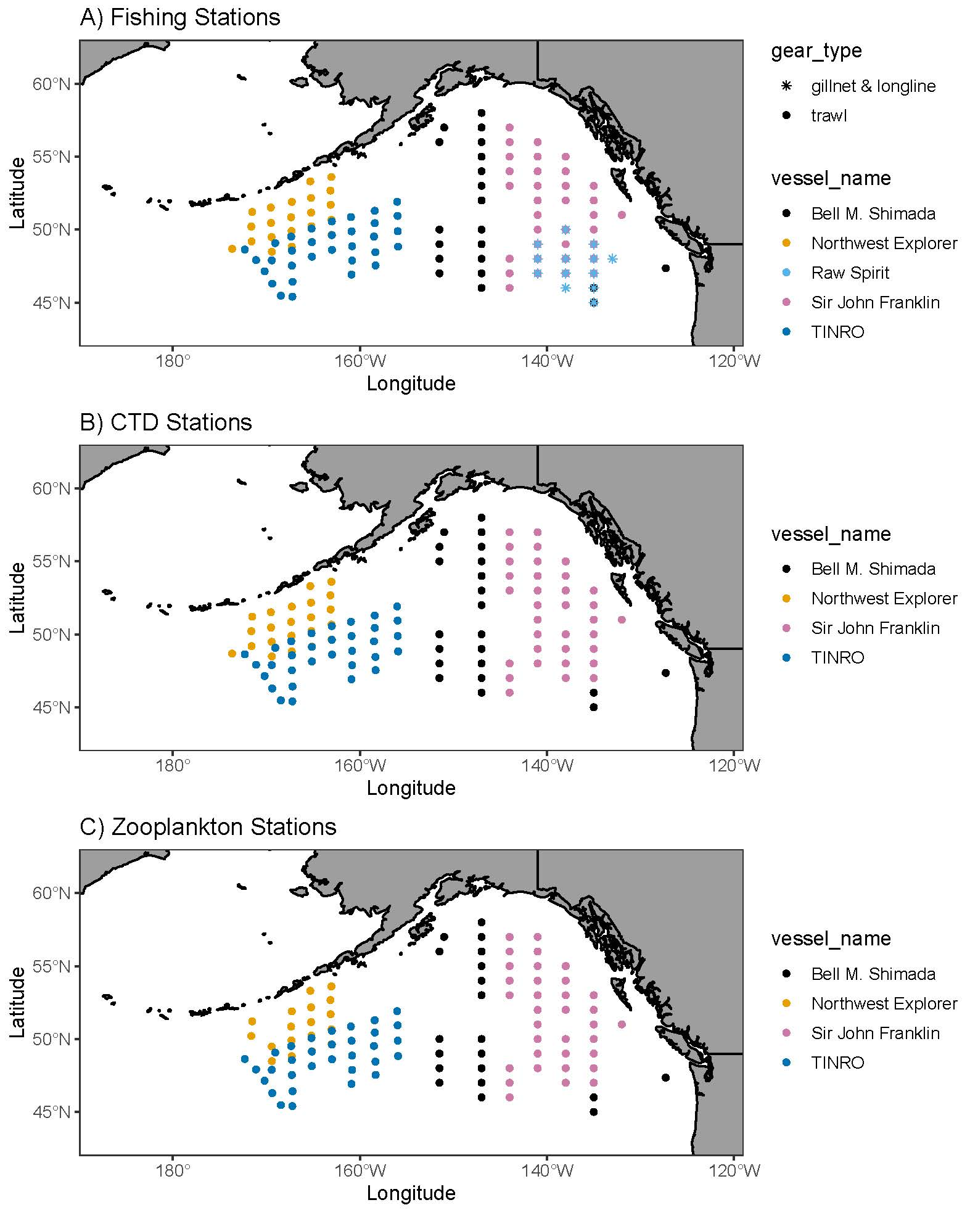**Figure 1.** Completed fishing, CTD, and zooplankton stations by the five vessels across the entire IYS survey grid, February 1-April 18, 2022. Stations sampled by the NOAA Ship *Bell M. Shimada* are in black, and include fishing at the two southern-most stations on the 135°W transect (overlaid by the F/V *Raw Spirit* icon).

**Figure 2.** Target sampling stations and actual stations sampled (with station number) by the NOAA Ship *Bell M. Shimada*, February 1-March 7, 2022. Table 1 lists gear deployed at each sampled station.

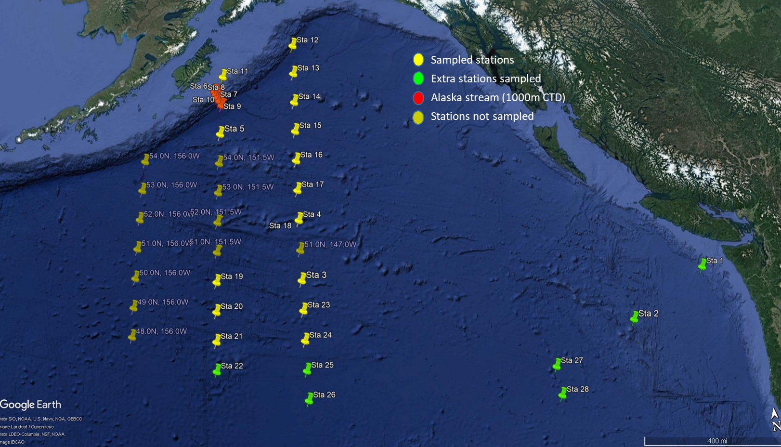

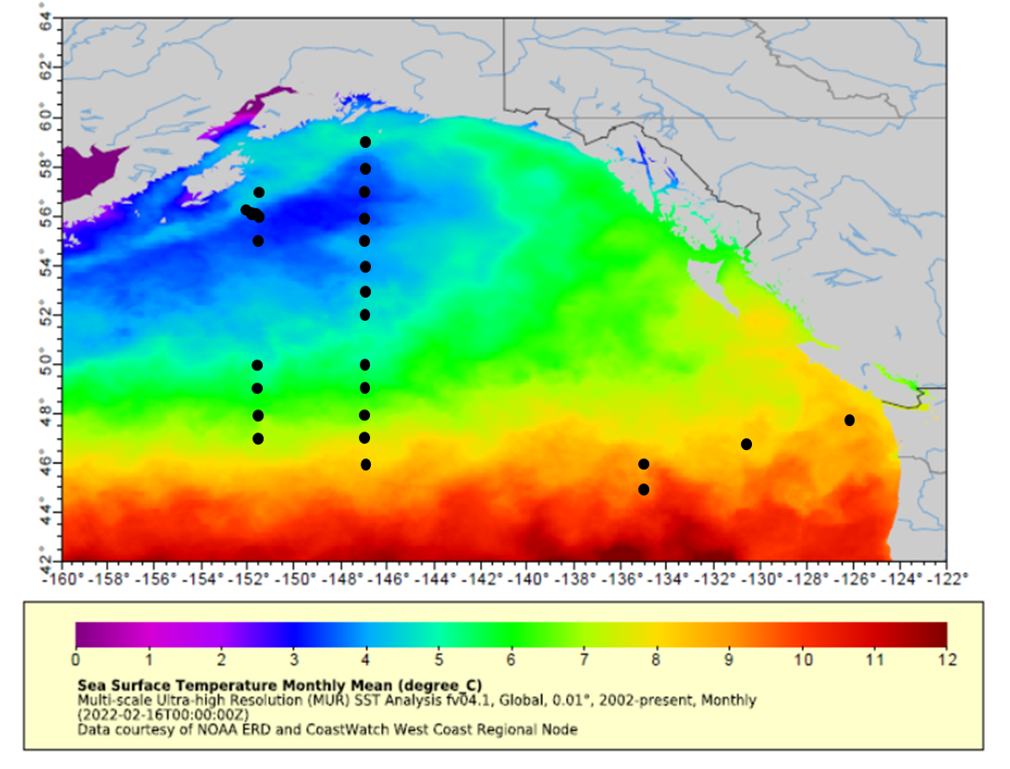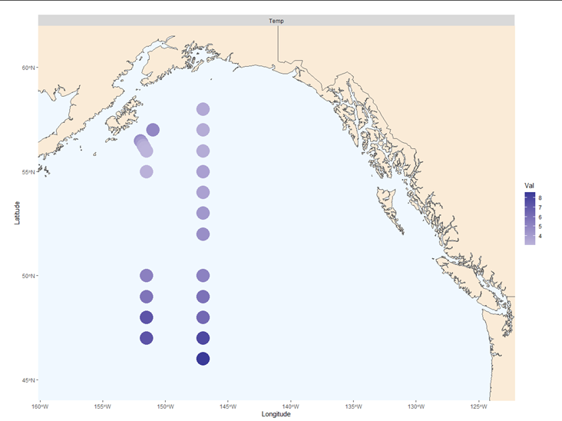**Figure 3.** Sea surface temperatures across the study area, showing both temperatures measured by the ship (top) and satellite-derived temperatures averaged for the month of February 2022, with sampled stations indicated (bottom; data from https://coastwatch.pfeg.noaa.gov/erddap/griddap).

**Figure 4.** Catch per unit effort (kg/hour trawled) of jellyfish, myctophids, squid, salmon and other fishes by the NOAA Ship *Bell M. Shimada*, February 1-March 7, 2022.

**Figure 5.** Catch per unit effort (number/hour trawled) of total salmon, other fish, myctophids, and squid by the NOAA Ship *Bell M. Shimada*, February 1-March 7, 2022.



**Figure 6.** Catch per unit effort (number/hour trawled) of Pacific salmon the NOAA Ship *Bell M. Shimada*, February 1-March 7, 2022.

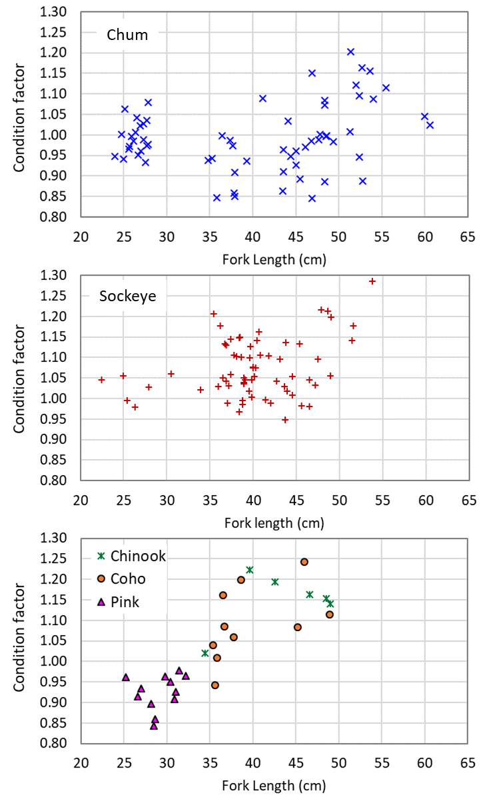**Figure 7.** Plots of fork length (cm) versus Fulton’s condition factor for chum (top), sockeye salmon (middle), and Chinook, coho and pink salmon (bottom) caught by the NOAA Ship *Bell M. Shimada*, February 1-March 7, 2022.

**References**

Pakhomov, E.A, C. Deeg, S. Esenkulova, G. Foley, B.P.V. Hunt, A. Ivanov, H.K. Jung, G. Kantakov, A. Kanzeparova, A. Khleborodov, C. Neville, V. Radchenko, I. Shurpa, A. Slabinsky, A. Somov, S. Urawa, A. Vazhova, P.S. Vishnu, C. Waters, L. Weitkamp, M. Zuev, and R. Beamish. 2019. Summary of preliminary findings of the International Gulf of Alaska expedition onboard the R/V Professor Kaganovskiy during February 16–March 18, 2019. NPAFC Doc. 1858. 25 pp. Canada, Japan, Korea, Russia, and USA (Available at https://npafc.org).

Pakhomov, E.A., R. Beamish, E. Farley, C. Freshwater, J. King, C. Neville, V. Radchenko, B. Riddell, S. Sato, A. Somov, S. Urawa, T. van der Stap, L. Weitkamp, C. Graham, and M. Saunders. 2021. Preliminary cruise plan for the NPAFC International Year of the Salmon (IYS) 2022 Pan-Pacific Winter High Seas Expedition. NPAFC Doc. 1995. 92 pp. (Available at https://npafc.org).

Somov, A., T. Blaine, C.M. Deeg, S. Esenkulova, T.J. Frost, S. Garcia, I.V. Grigorov, B.P.V. Hunt, A. Kanzeparova, R.V. LaForge, J.E. Lerner, N. Mahara, C.M. Neville, E.A. Pakhomov, B. Riddell, W.W. Strasburger, and R.J. Beamish. 2020. Preliminary findings of the second salmon Gulf of Alaska expedition onboard the R/V Pacific Legacy March 11–April 7, 2020 as part of the International Year of the Salmon. NPAFC Doc. 1930. 48 pp. Russia, Canada, and USA (Available at https://npafc.org).